

**KK14203 OBJECT ORIENTED PROGRAMMING**

**SEMESTER II**

**SESSION 2019/2020**

**ASSIGNMENT 2**

LECTURER: Madam Siti Hasnah Tanalol

|  |  |
| --- | --- |
| Name | Matric No |
| NUR NAJWA KHAIRINA BINTI MOHD KHAIRI | BI19110039 |

**Introduction**

Handling a small business such as mini mart should not be much of a problem. However it’s always better to have a system that will help to keep things more organized. When working in a mini mart, of course stocks need to be managed properly so we could keep track of how much of each item is still available. This is so we will know when to order a new batch of stock. This system is to help manage the stocks in the mini mart.

**Objectives**

1. To save record of all bookings made.
2. To add new stocks.
3. To be able to keep track of the amount of stock left.
4. To know when the stocks is running out and needs to be restocked.
5. To implement GUI to make the system easier to use.

**Stock Bookings**

This class is to keep record of all bookings that has been made. This is to make sure that every booking is delivered successfully. The class also keeps record of the contact information and company, so if there’s any complaint regarding the bookings, the company could be contacted.

The coding is as shown below :

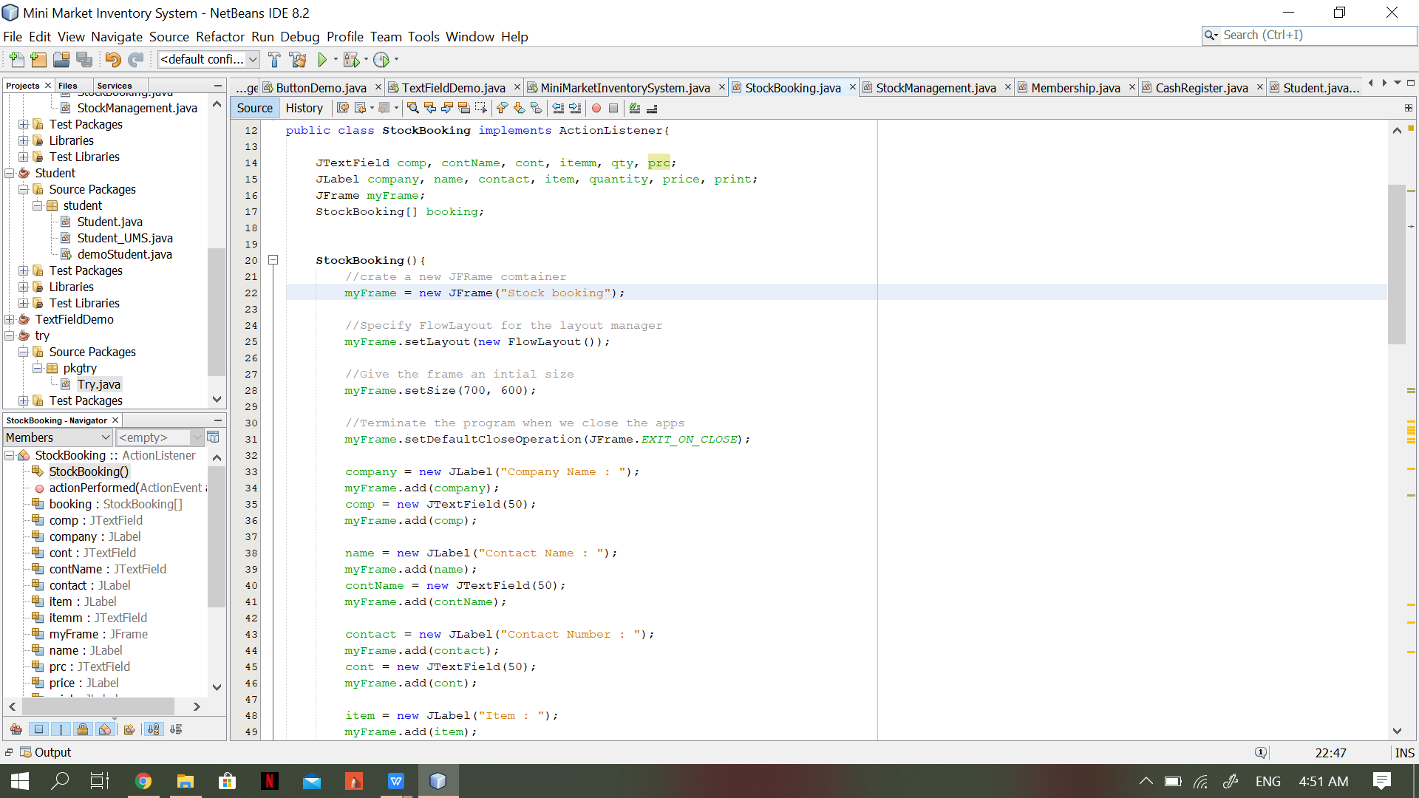

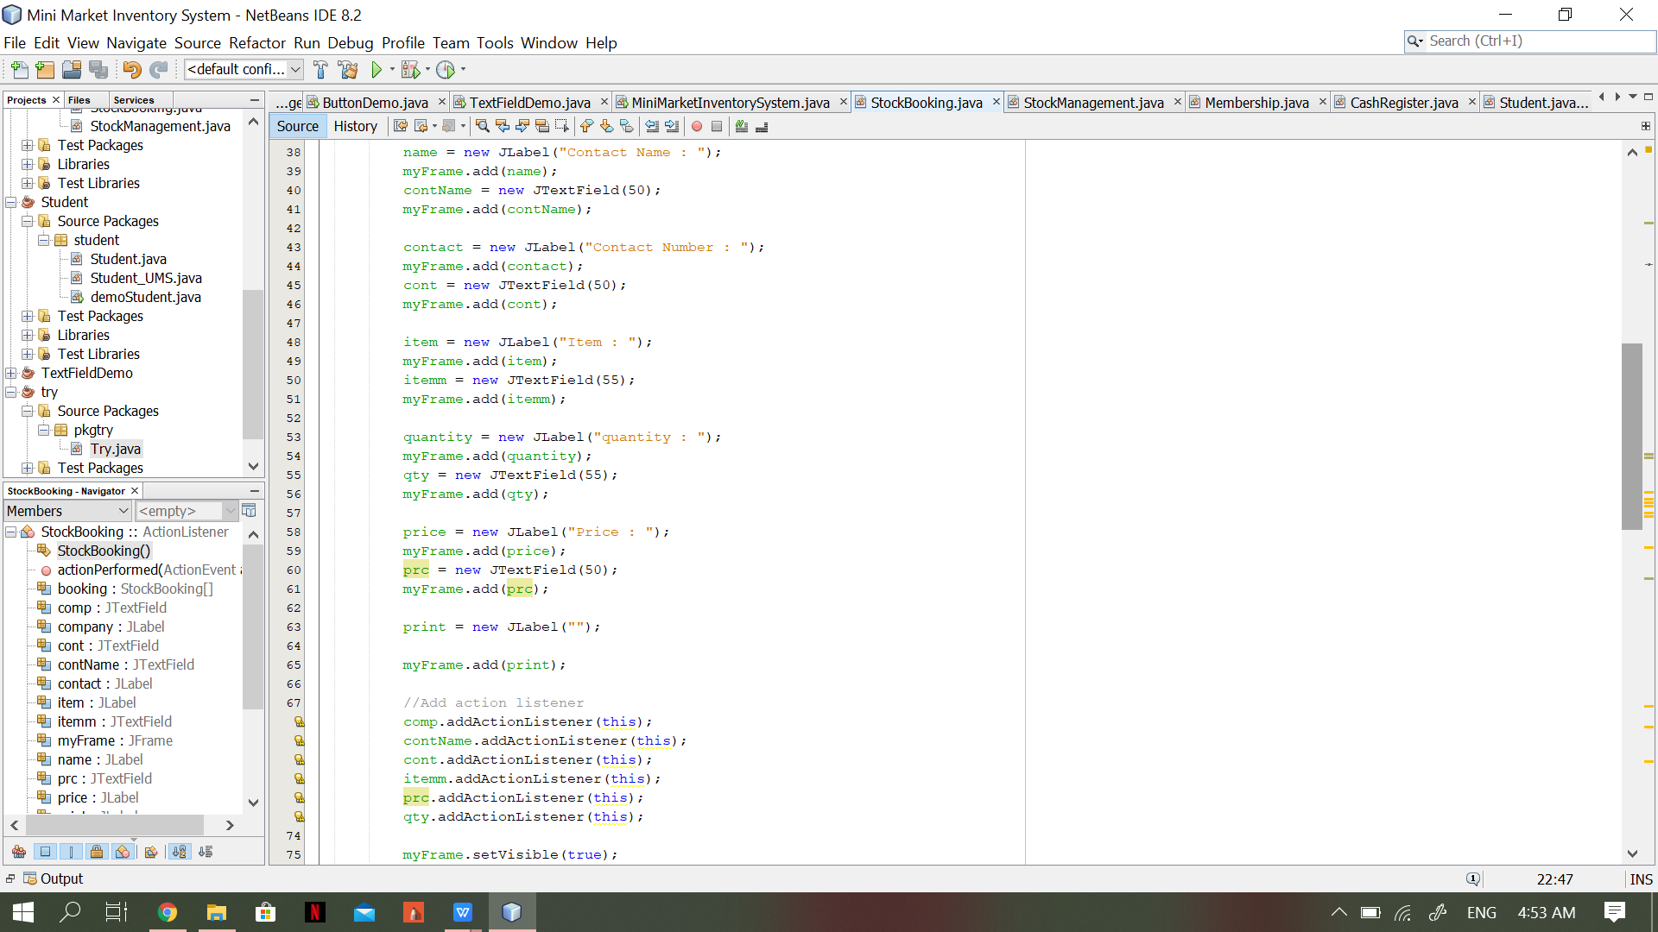

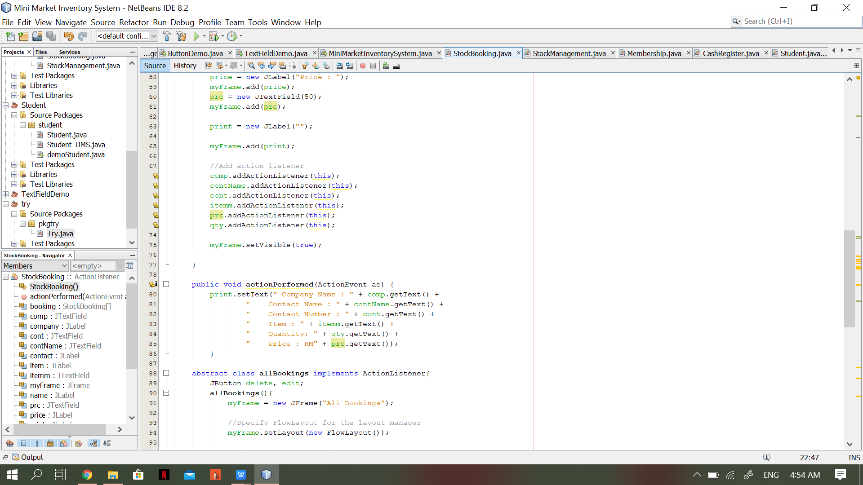

Below is the output :

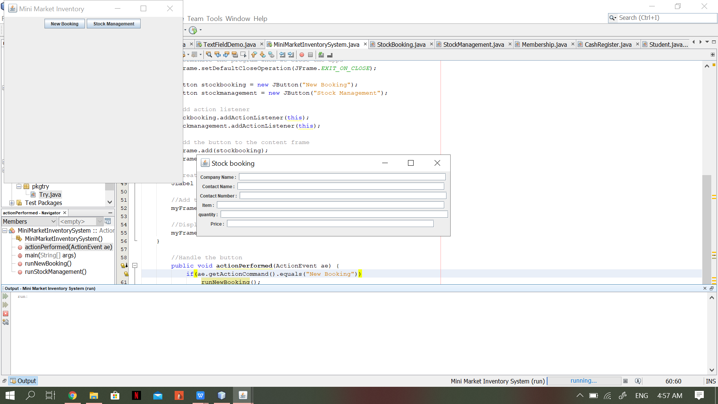

**Stock Management**

This class is to keep track of the amount of stock left in the store. The value needs to be updated by the user.

This coding is as shown below :

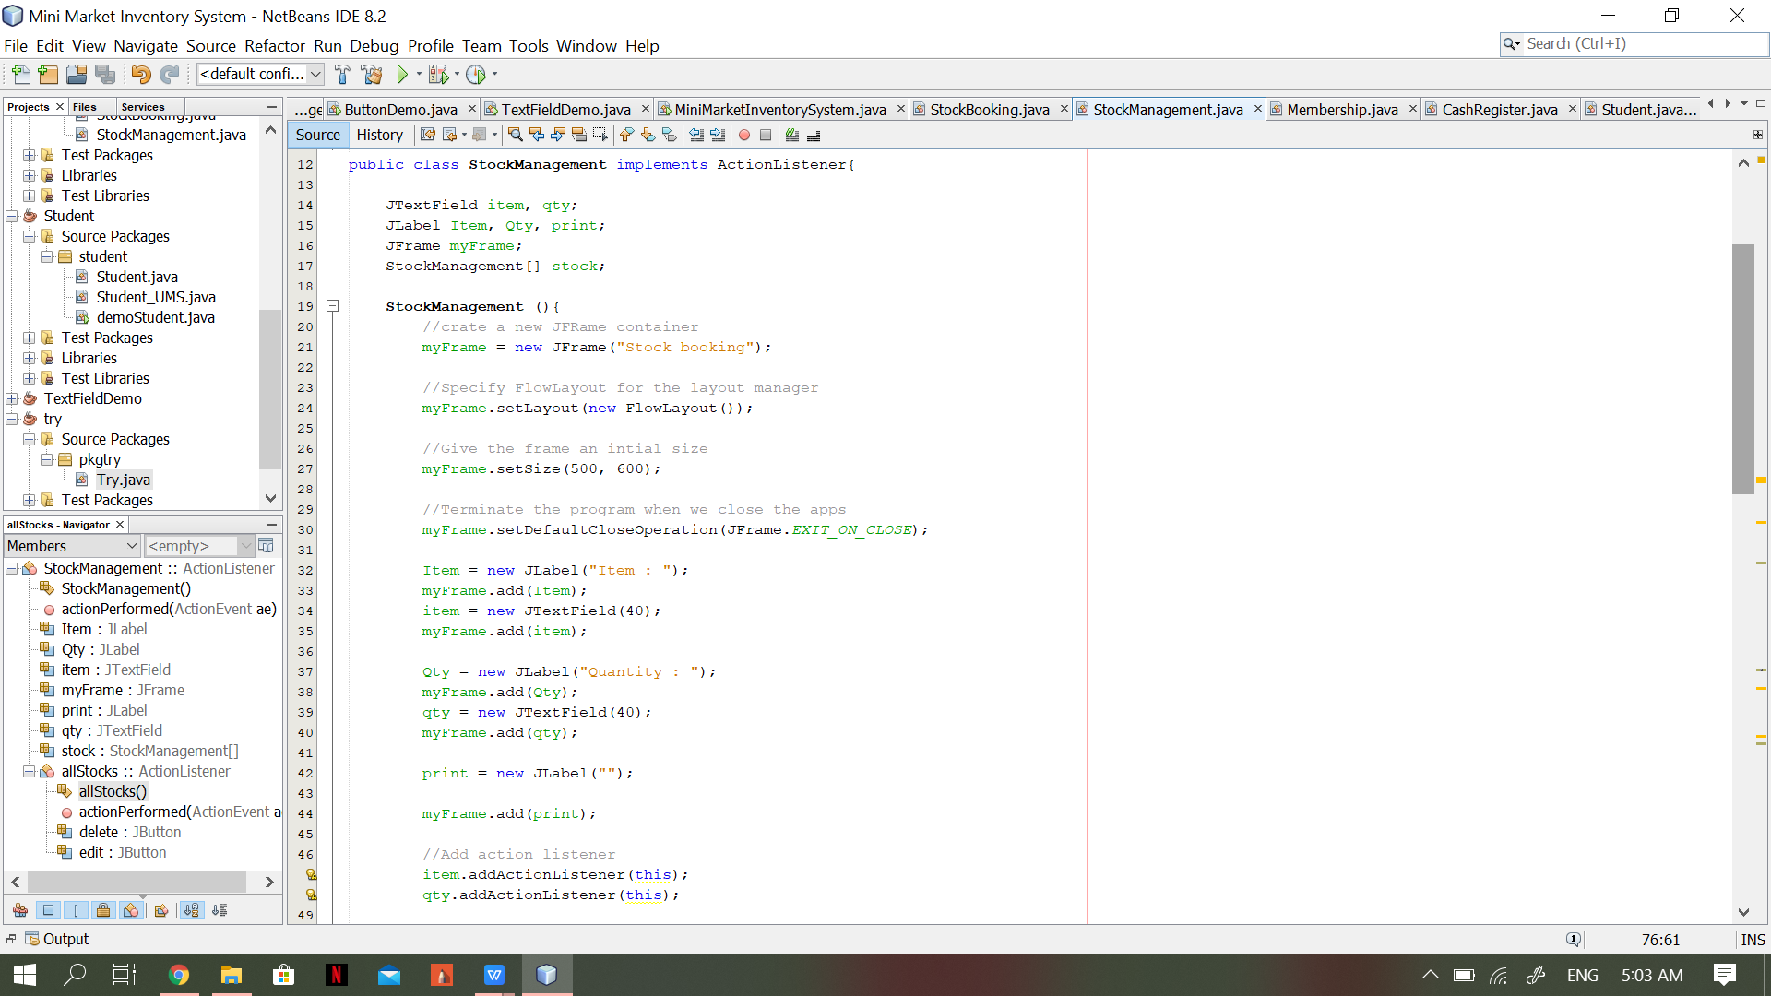

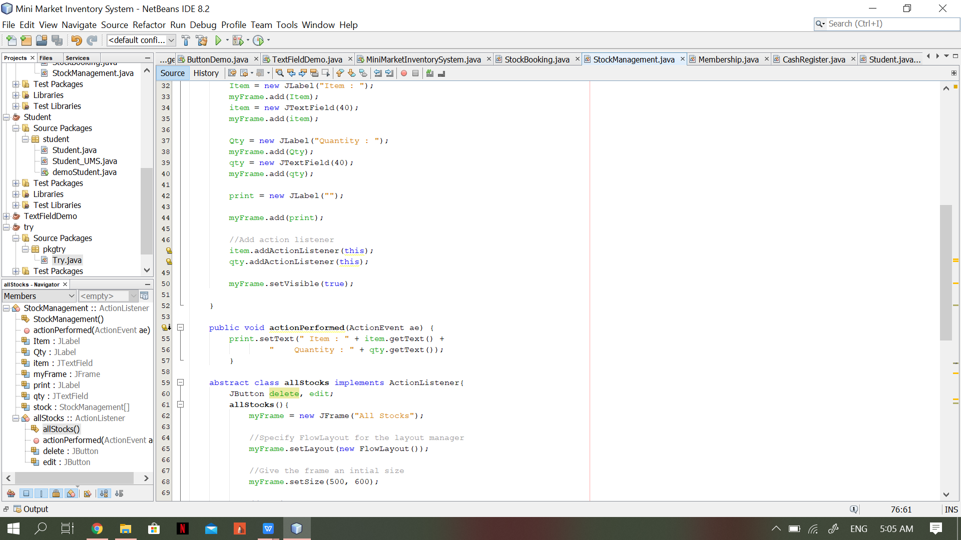

Below is the output :

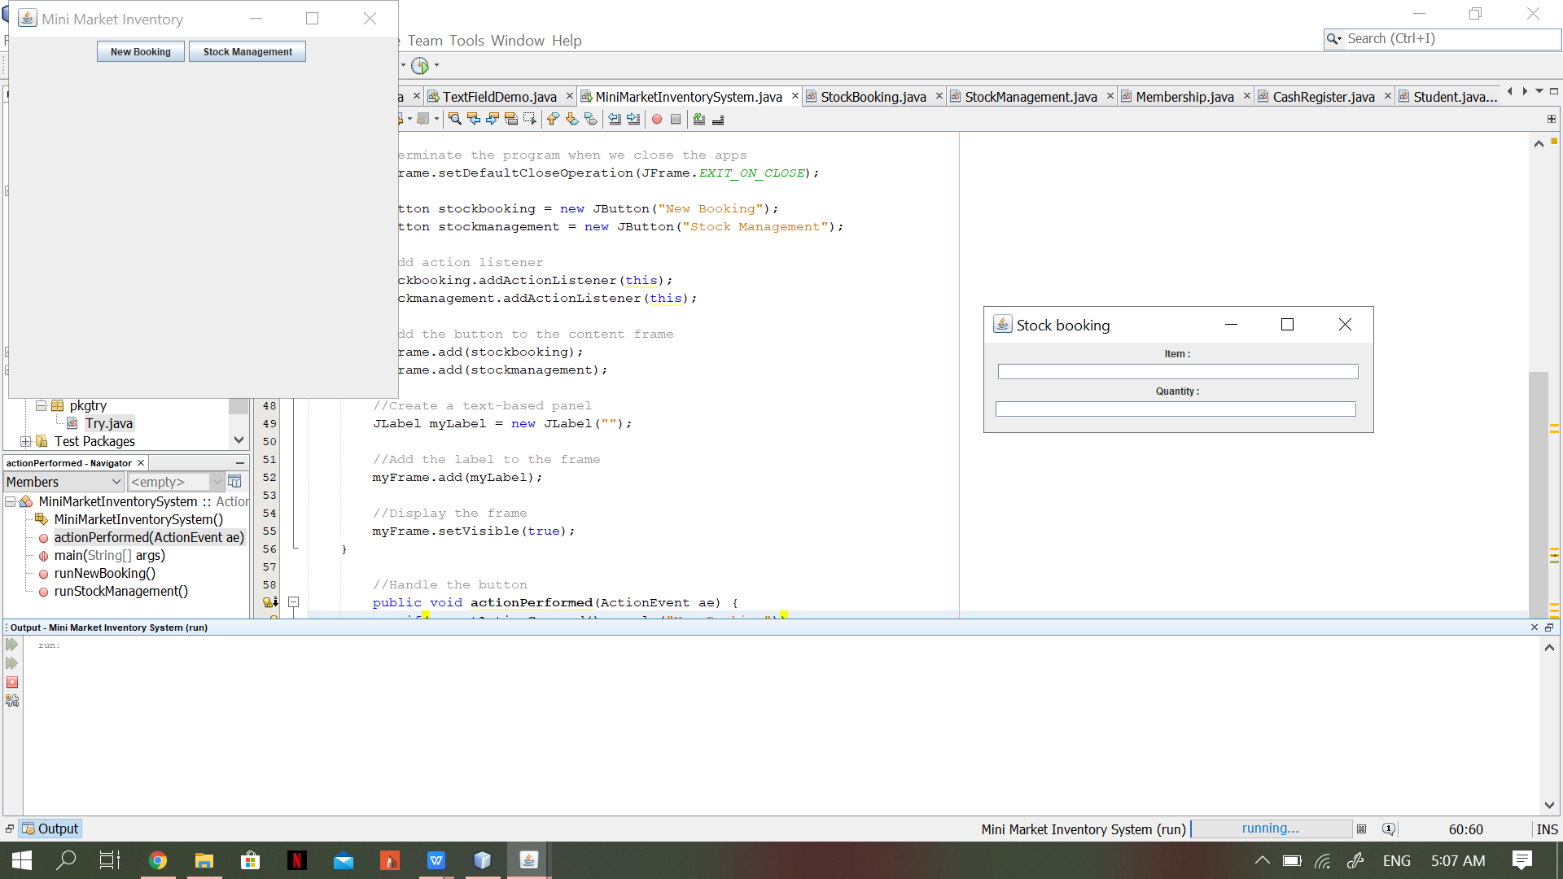

**Main**

This is the main method of the entire project.

The coding is as shown below :

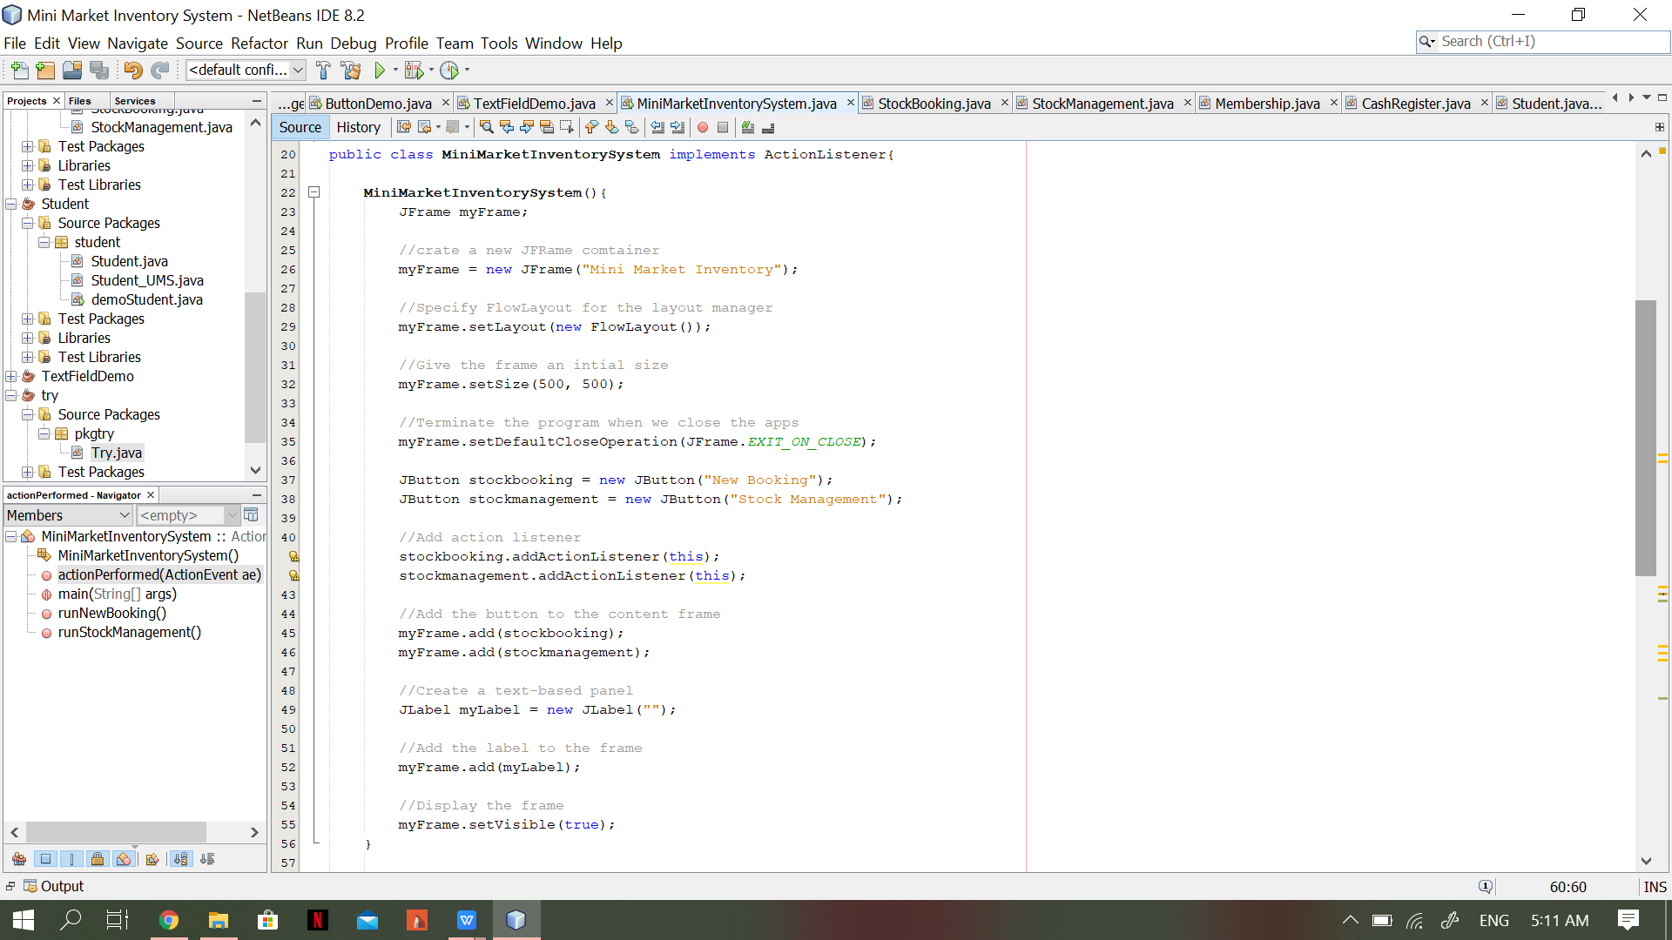

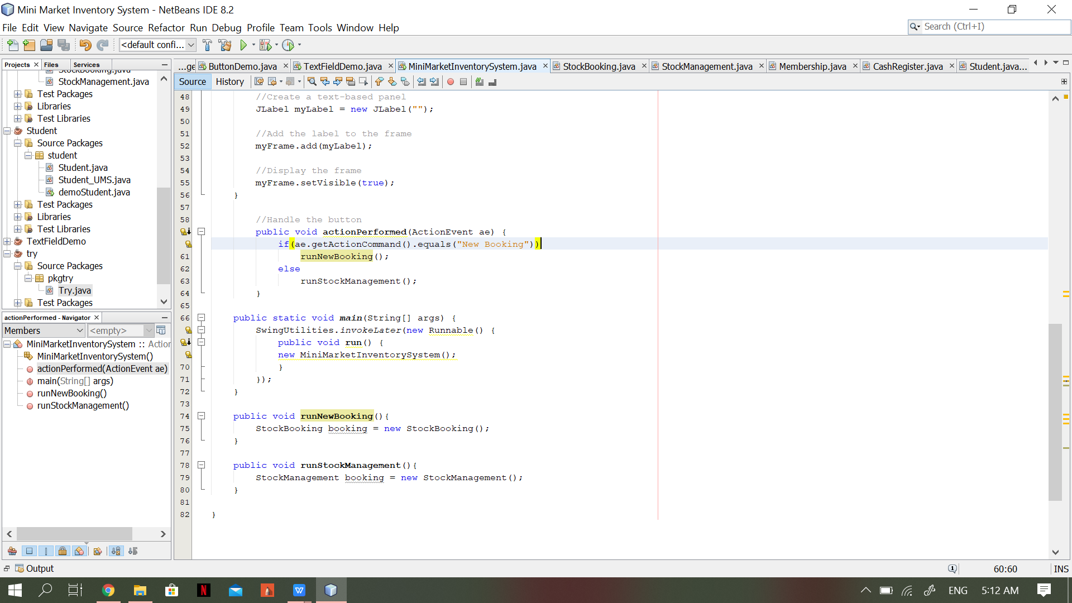

The output is as follows :

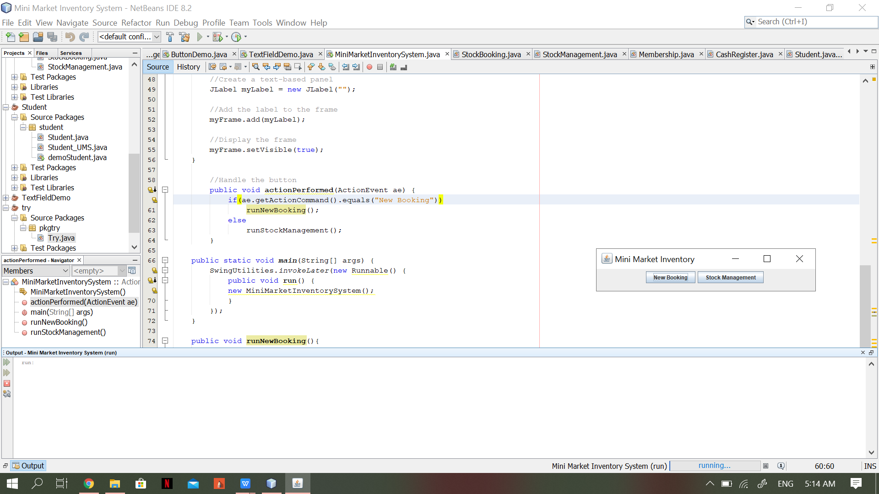

**User Manual**

Upon opening the system, user will see a window with two buttons, ‘New Bookings’ and ‘Stock Management’.



Button ‘New Booking is for the user to key in information regarding their stock booking to be stored in the system. The informations that needs to be filled are the company name, the person or employee that receives the orders for the booking, the contact info, the item booked, its quantity and the price paid.

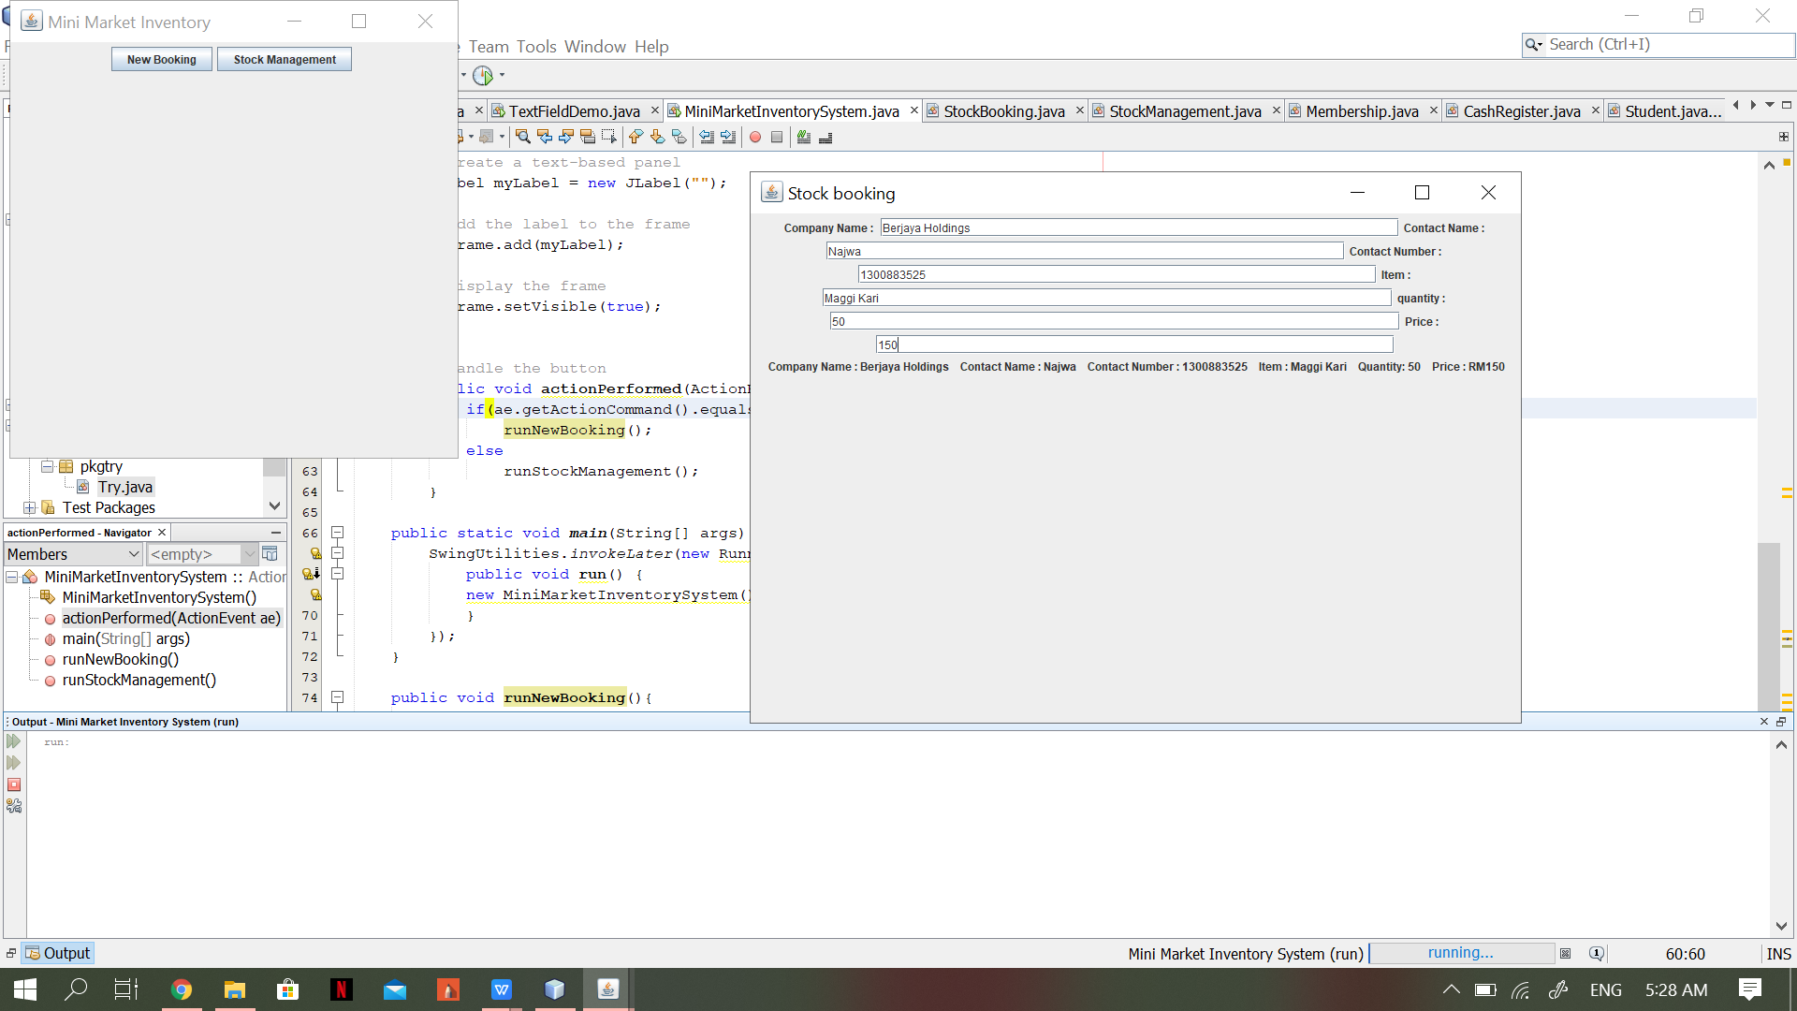

Button ‘Stock Management’ is for the user to add new stocks. When the button is clicked, another window will appear that will requires user to filled in the item in the stock and its quantity.

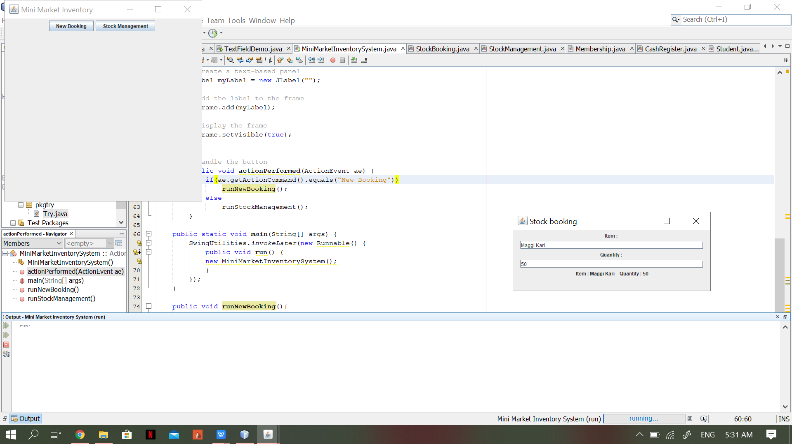

**Conclusion**

By developing this program, management for mini market inventory can be done easily and requires a shorter time. Besides, they can organize and manage stocks efficiently. Furthermore, this program can create a smooth inventory system in the market and control all the activities to improve the profit. The development of the program requires programming knowledge in the use of Java. It is important to pay equal attention to the development of the program codes and the designing of the user-friendly program.